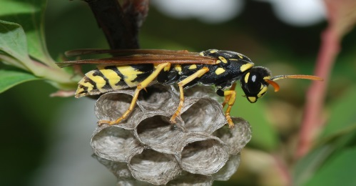

**Same Day Solutions - No Contracts - Great Prices - Warranties - Emergency Services**

Summer Newsletter

**Our Summer Services:**

**General Preventative:**

Treats the exterior and interior of your home for: spiders, ants, and other common household pests.

**Bees, Yellow Jackets, and Wasps:**

Our professional technicians with protective gear can remove Wasp nests and beehives. Insecticides are also used.

**Wildlife Trapping:**

We provide animal safe traps and re-location to all animals you may be having a problem with such as:

Rabbits, Squirrels, Skunks, and Raccoons.

**Voles & Prairie Dogs:**

Call us today to learn about our Vole and Prairie Dog control system.

**Mice & Rats:**

Using our professional tamper resistant containers and bait, allow us to get rid of your common field mouse, and get the rats away from your property!

**Bees, Yellow Jackets, and Wasps:**

Bees, wasps and yellow jackets are dangerous because of their painful and potentially harmful stings. There are many different Yellow Jackets, and Wasps that are bothersome in the Denver Area. These pests can nest in walls, ceilings, attics, and various areas outside. Some species are very aggressive especially when nests are disturbed.

**If you get stung:**

1. Remove the Stinger – scrape the area with a fingernail or use tweezers to remove it. Don’t pinch the stinger that can inject more venom.
2. Control Swelling – Ice the area! If you were stung on your arm or leg elevate it. Remove any tight fitting jewelry from the area of the sting.
3. Treat Symptoms – For pain take an antihistamine like Benadryl.
4. Seek assistance immediately if the sting victim has:

* Trouble breathing
* Feelings of faintness or dizziness
* Hives
* A swollen tongue
* A history of severe allergic reaction to insect stings

Phone: (303) 627-5800

Fax: (303) 627-5801

E-mail: apcc@earthlink.net

Pest Control Company llc.

**What should I expect this season?**

**Mice:**

Mice breed year-round, but when living outdoors, they breed mostly in spring and fall. A female may have 5 to 10 litters per year. Mice can fit through openings the size of a dime and they can be very hard to control. 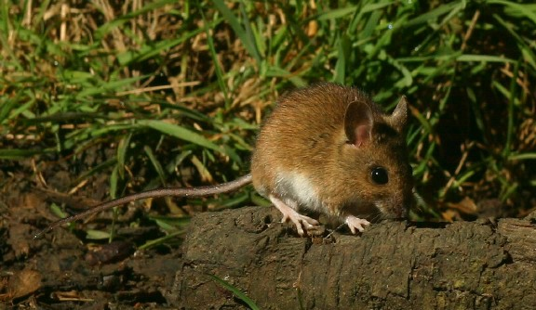

**Spiders:**

As warm weather approaches, so does the chance of a higher spider population in and around your home. When it gets closer to spring, female spiders begin to lay anywhere from one to thousands of eggs in an egg sac and these eggs normally take a couple of weeks to mature and hatch. If you are seeing spider presence in your home call us today for an inspection and general preventive treatment.

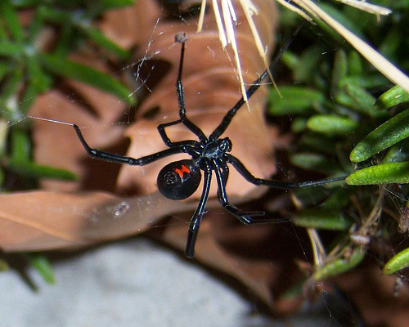

**American**